**INTEGRATING ANDROID STUDIO WITH GITHUB**

**Table of Contents**

**1.** **Document Control** 2

1.1. Change Record 2

1.2. Reviewers/Approvers 2

**2.** **INTRODUCTION** 3

**3.** **Install Git on local system** 3

**4.** **Set up the global configurations on the Git** 3

**5.** **Generate and Add the SSH Key on GitHub** 4

**6.** **Android studio Integration with GitHub** 5

# **Document Control**

The purpose of document control is to track all changes and updates made to management procedures and serves to function as version control.

## Change Record

|  |  |  |  |
| --- | --- | --- | --- |
| **Date** | **Author** | **Version** | **Change Reference** |
| 09/26/2019 | Lokesh Makkineni | 0.1 | Draft Document |
|  |  |  |  |
|  |  |  |  |
|  |  |  |  |
|  |  |  |  |



## Reviewers/Approvers

|  |  |  |
| --- | --- | --- |
| **Date** | **Name** | **Comments** |
| 09/26/2019 | Shipra Agarwal/Supriya Pawal |  |
|  |  |  |
|  |  |  |
|  |  |  |

# **INTRODUCTION**

This document is an overview document on setting up the Git on developer’s machine and integration with GitHub. This document also details the steps to work with GitHub repositories from IDE Android studio.

# **Install Git on local system**

* Download the Git software (exe file) from below site and run the executable file.

<https://git-scm.com/>

* Open the GitBash terminal and check the version of Git to verify successful installation of Git.

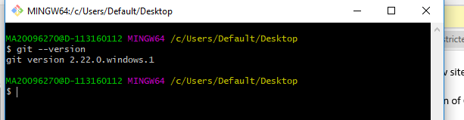

# **Set up the global configurations on the Git**

* Open the GitBash and set user name, email Id etc.

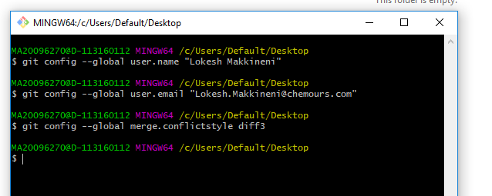

* Verify the configured details with the below command

git config - -list

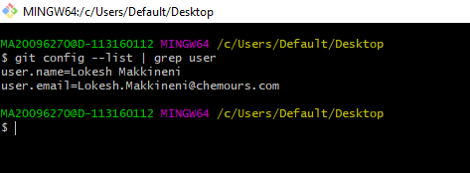

# **Generate and Add the SSH Key on GitHub**

* Open the GitBash terminal and execute the below command

ssh-keygen –t rsa –C “useremailid@chemours.com”

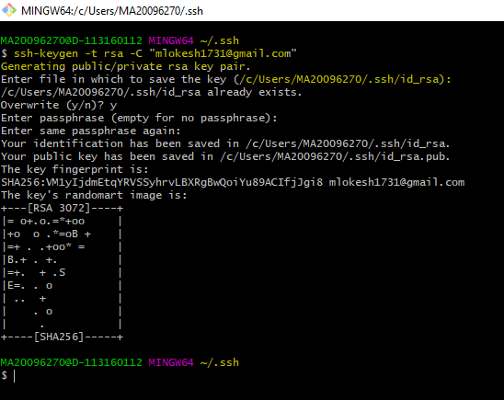

* Copy the public key

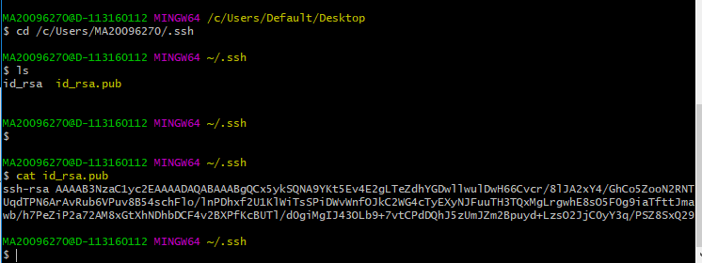

* Add the SSH Key on GitHub Account.

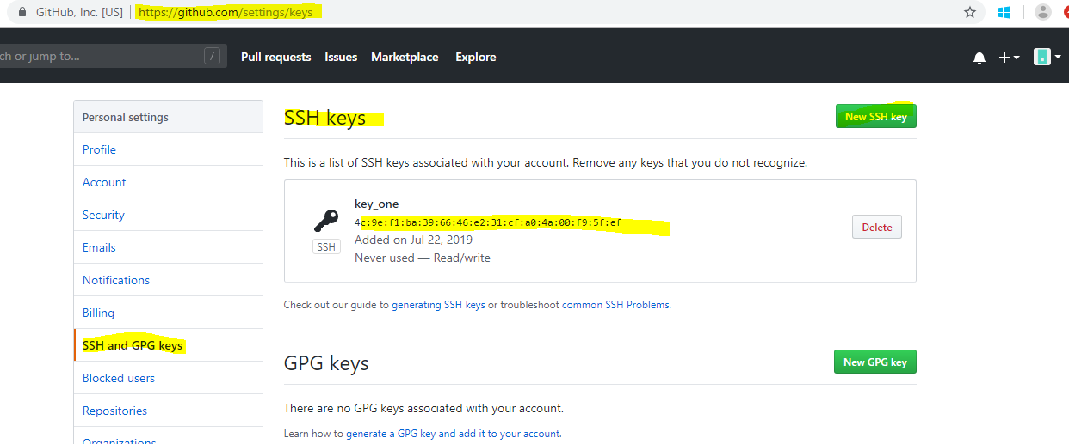

# **Android studio Integration with GitHub**

* Access Android studio
* Now, go to ‘File’ –> ‘Settings’ –> ‘Version Control’ –> ‘GitHub’.
* Add your GitHub credentials. And then click ‘Test’ to ensure that GitHub connection.

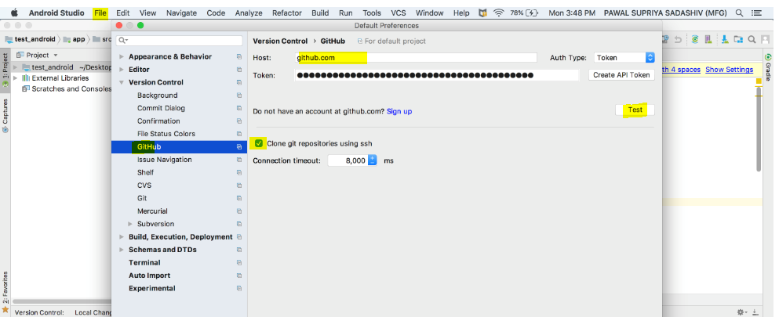

* Enable Version Control Integration
* Select ‘VCS’ –> ‘Enable Version Control Integration…’ to enable version control for the current project. Choose the version control as GitHub.

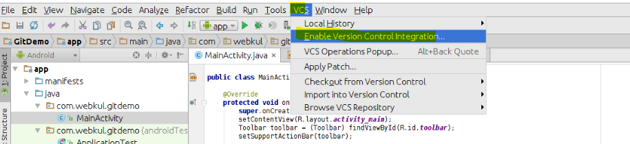

* Clone the repository from the GitHub
* VCS 🡪 Checkout from version control 🡪 Git

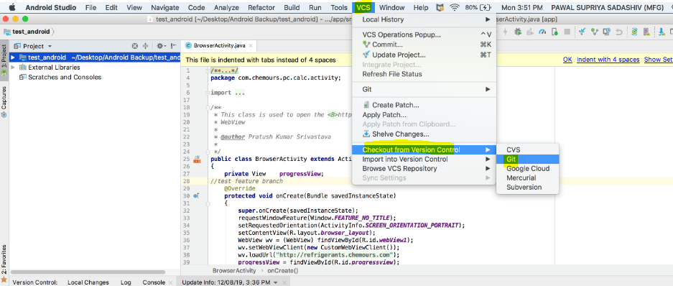

* Provide git repository URL and local path to clone.
* Checking out to required/working branch

VCS 🡪Git 🡪 Branches

* Click on checkout as and select the branch to be checkout.

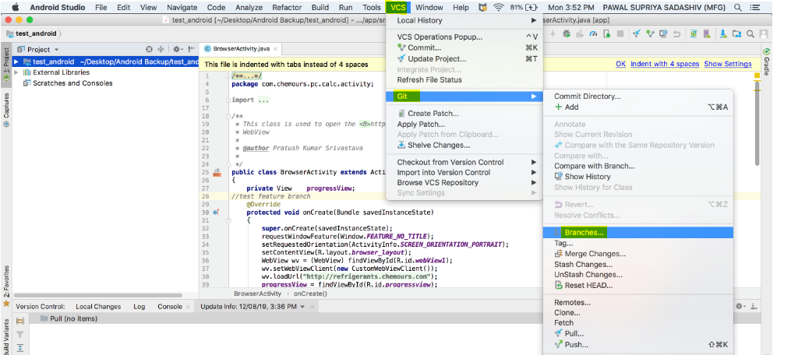

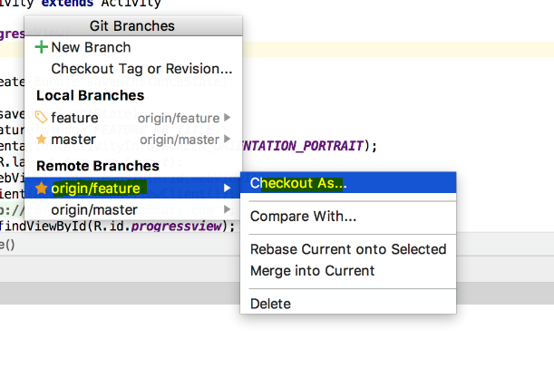

* Git ADD and COMMIT

Make Changes In The File And Pushing To The Repository

If we want to reflect any changes to our repository done in the project.to add any changes made, press VCS commit changes button (Ctrl +K) this will automatically add all the files after ignoring from the list of file mentioned in .gitignore.

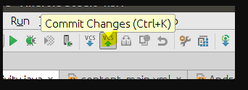

Provide proper commit message and select the files (click the check box) to be committed.

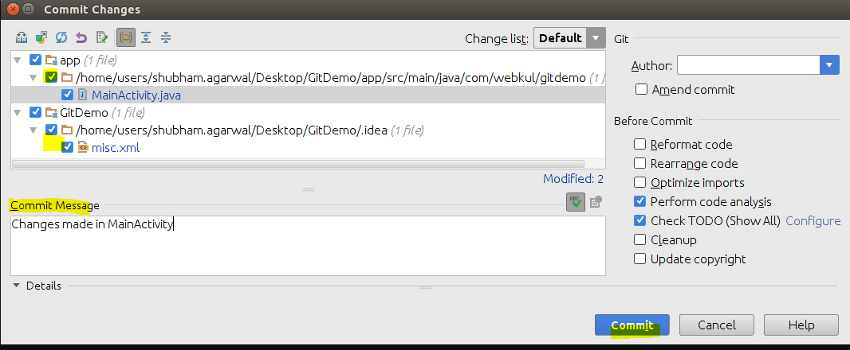

* PUSH and PULL

VCS 🡪Git 🡪 PUSH/PULL

